VERILOG CODE:

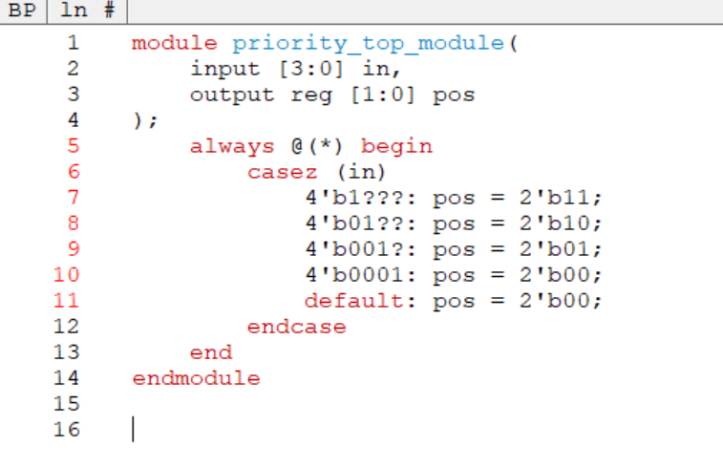

TESTBENCH CODE:

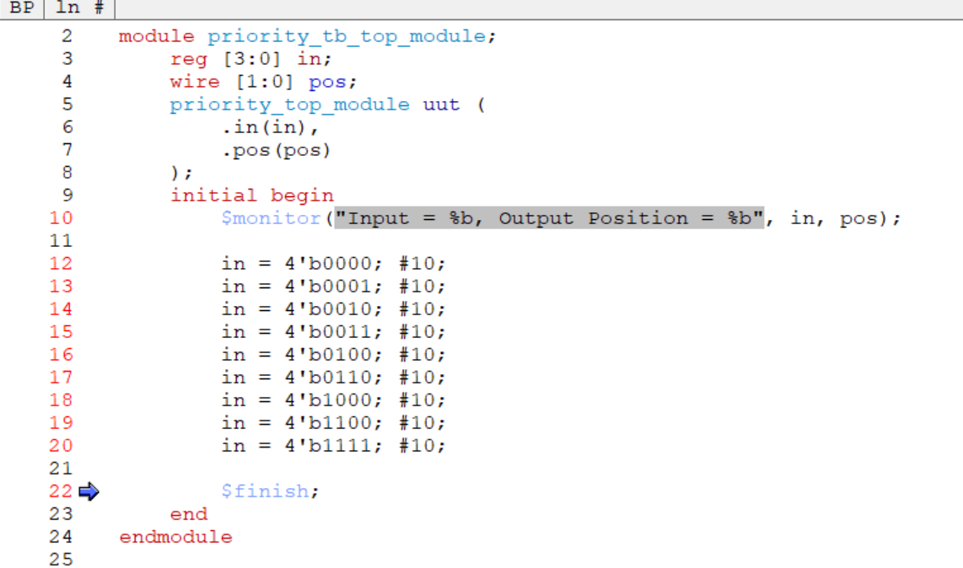

RESULTS:

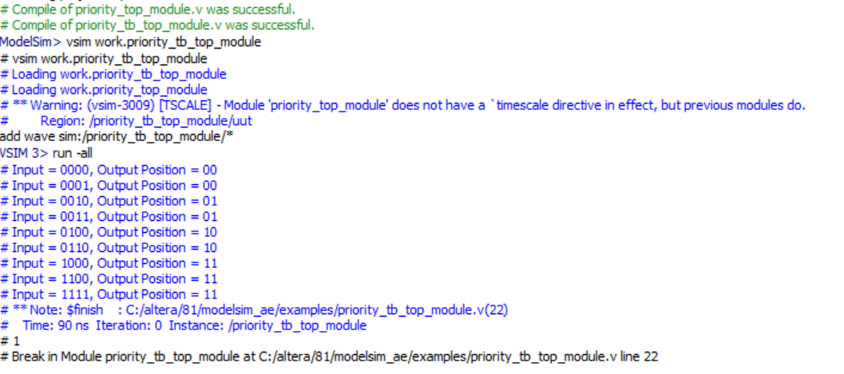

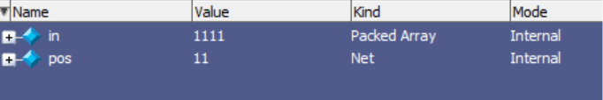

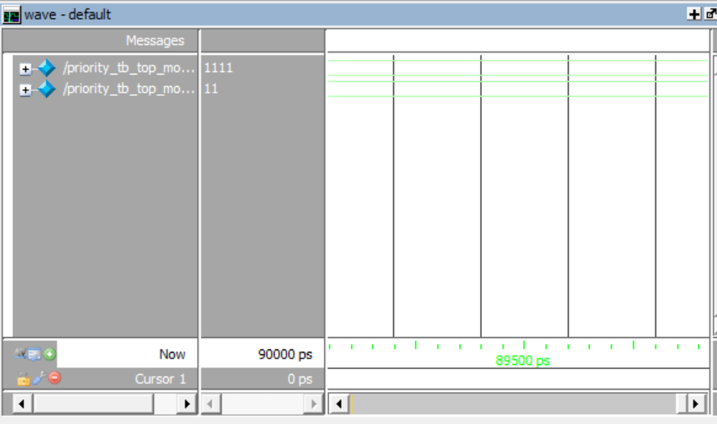

NAME:SAI TEJO VAISHNAVI MIDATHANA REG NO: 126004230